## **Question 1: Logic Gates with Neural Network**

### **Python Code**

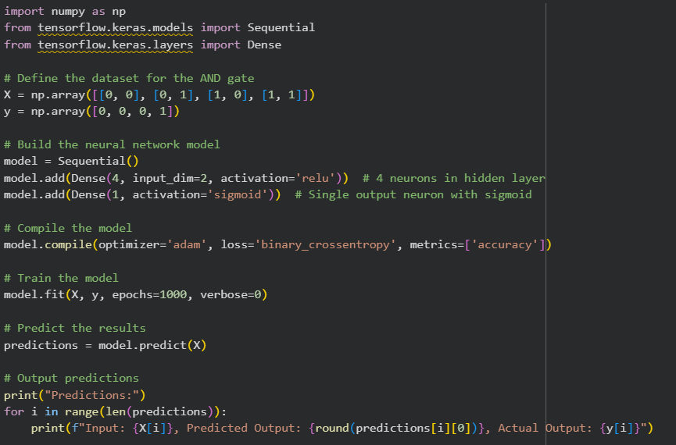  
  
**OUTPUT  
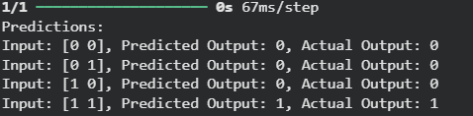**

## **Question 2: Regression Task with Neural Network (y = x² + noise)**

### **Python Code**

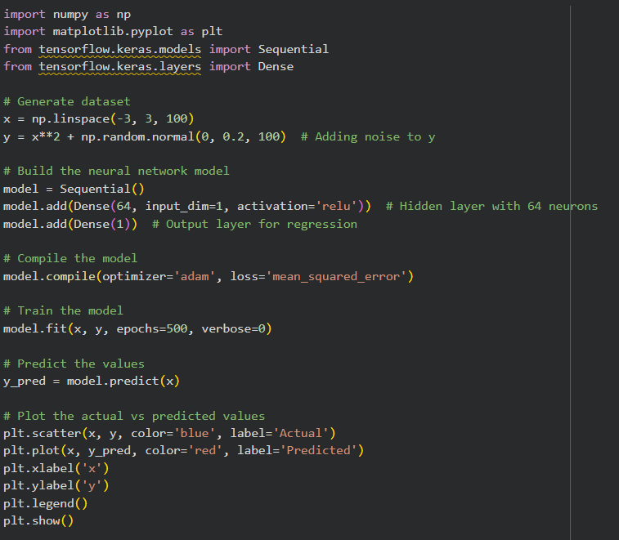

**OUTPUT  
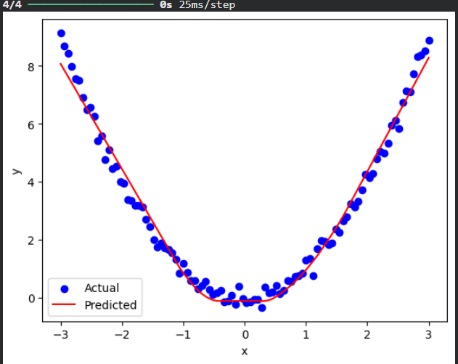**

## **Question 3: XOR Gate with Neural Network**

### **Python Code**

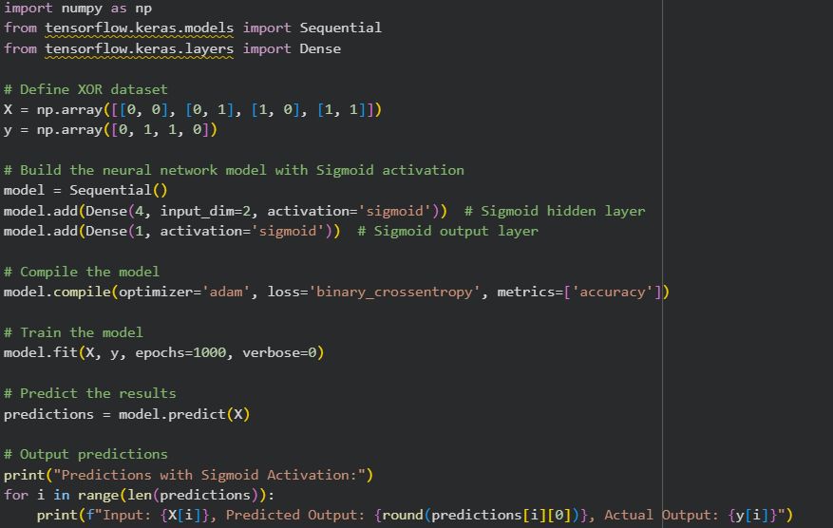

**OUTPUT**

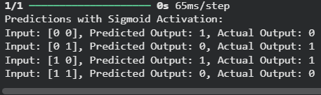

## **Question 4: Multi-Class Classification on Iris Dataset**

### **Python Code**

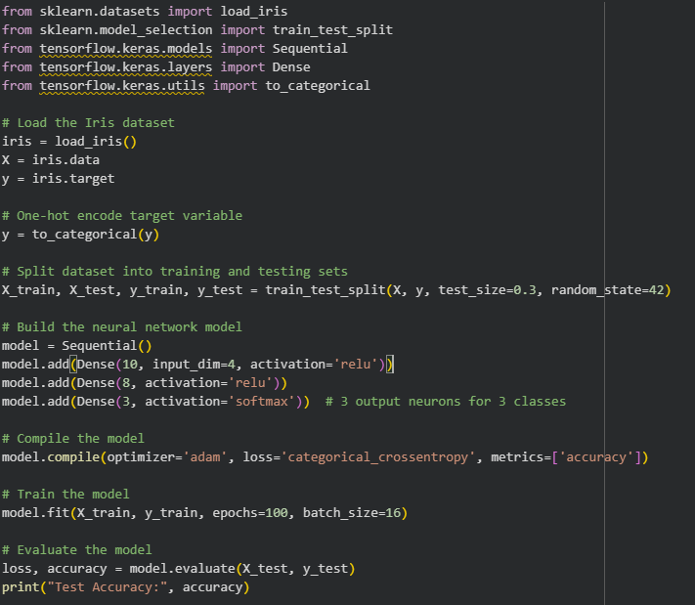

**OUTPUT**

